Midterm – Part 2: Parallel Computing
Screenshots for Tasks 1 & 2:
Coding Task 1:
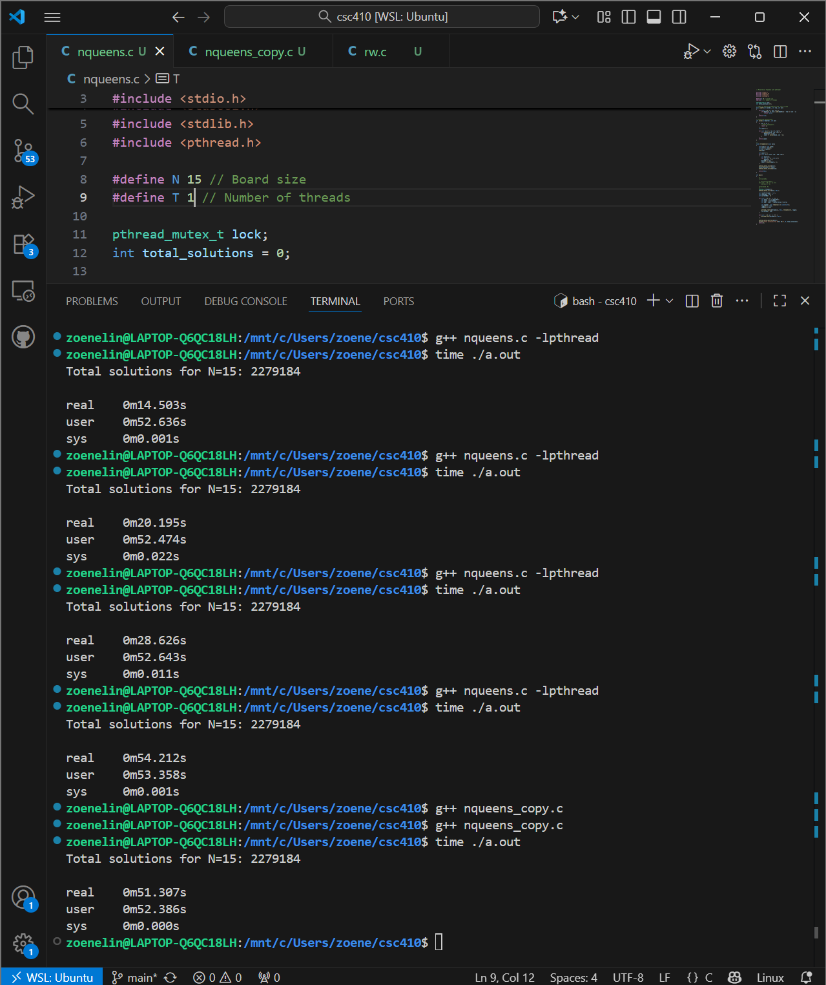

Coding Task 2:
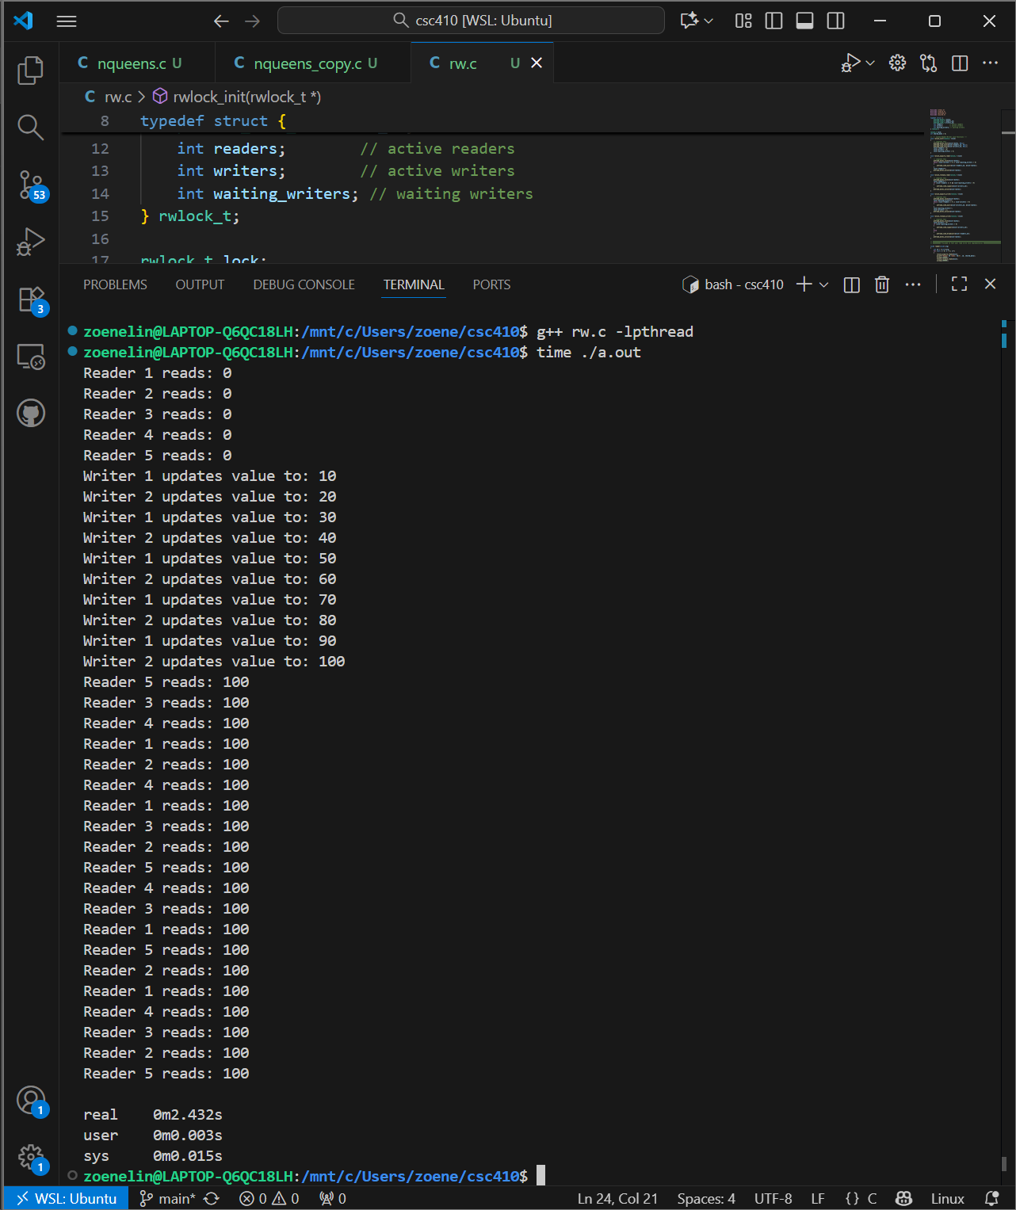

Task 3:
N Queens (for N = 15)
 | Sequential | 1 thread | 2 threads | 3 threads | 4 Threads
Time | Real  0m51.307s | Real 0m54.212s | Real 0m28.626s | Real 0m20.195s | Real 0m14.503s
Observations:
The time for the N Queens program to execute sequentially and with 1 thread is very similar. The sequential program runs approximately 3 seconds faster than the parallelized program with 1 thread, which may be due to the overhead. With 2,3, and 4 threads we begin to see real results in the speedup of time. By just adding a second thread we gain 26 seconds in execution time, the greatest gain in time is with the addition of the second thread. After adding 3 and/or 4 threads we still see an improvement in the time for the N Queens program to complete, but this time improvement scales less with each additional thread, the speed up time starts to diminish.

Research Task 4:
1. Restrict Solution:
This approach uses a counting semaphore initialized to N − 1 to limit the number of philosophers who can attempt to pick up forks and eat at the same time. By ensuring that only N − 1 philosophers enter the eating phase at once, it prevents a deadlock scenario where all philosophers pick up their right fork and wait for the left. Deadlock is avoided because at least one philosopher is always left thinking, breaking the circular wait. If the semaphore is implemented with fairness such as FIFO scheduling, starvation is prevented, as each philosopher eventually gets a turn. This solution is simple to implement and allows more philosophers to eat. It works reliably for small to medium values of N. However, using a shared control point adds some overhead, and performance can drop if many philosophers try to eat at once. Also, fairness must be built in to fully prevent starvation.

2. Tanenbaum’s Monitor Solution:
This method uses a monitor pattern to manage philosopher states and fork access. Each philosopher maintains a state of thinking, hungry, or eating, and each philosopher has its own semaphore. A philosopher can only proceed to eat if both neighbors are not currently eating. This design breaks circular wait and avoids deadlock. However, starvation is still possible if a philosopher is repeatedly denied access due to timing. The Tanenbaum Monitor is a great parallelism option, as multiple non-adjacent philosophers can eat simultaneously. It also avoids the need for a global lock. On the downside, starvation is not prevented unless fairness is added, and the solution requires handling of state transitions like that of thinking, hungry, or eating. It’s slightly more complex than other approaches due to the need for state tracking and conditional signaling.

3. Fair Tanenbaum Solution:
This is the enhanced Tanenbaum’s monitor that includes fairness by tracking how many times each philosopher has eaten. Philosophers are prioritized who have eaten less then other philosophers, promoting fairness so that all philosophers can eat and not starve. Like the original monitor, it remains deadlock-free by checking neighbor states before allowing a philosopher to eat. Starvation is not completely impossible in this solution, as timing can still affect access. This approach improves fairness and offers a good balance between performance and equal resource sharing. However, it introduces additional complexity and overhead due to state tracking and prioritization logic and as a result, is less scalable for large N due to increased CPU and memory demands.

Sources
- https://diningphilosophers.eu/semaphore/#:~:text=Table%20Semaphore%20Solution,fairness%20parameter%20to%20prevent%20barging.&text=Philosopher%20class:%20Philosophers%20need%20to,they%20are%20finished%20picking%20up.
- https://www.geeksforgeeks.org/operating-systems/dining-philosopher-problem-using-semaphores/
- https://see.stanford.edu/Course/CS107/211
- https://codewitharyan.com/tech-blogs/the-dining-philosophers
- https://www.stolaf.edu/people/rab/pdc/text/dpsolns.html#:~:text=The%20waiter%20solution%20to%20Dining%20Philosophers&text=Strategy:,first%2C%20then%20their%20right%20chopstick
- https://eng.libretexts.org/Courses/Delta_College/Operating_System%3A_The_Basics/06%3A_Deadlock/6.4%3A_Dining_Philosopher_Problem

